Department of Computer Science and Engineering

BRAC University
CSE 260: Digital Logic Design

Experiment # 10

Data Transfer using Shift Register and Implementation Ring Counter.

Register that is capable of shifting data one bit at a time is called a shift register. The logical configuration of a serial shift register consists of a chain of flip-flops connected in cascade, with the output of one flip-flop being connected to the input of its neighbor. The operation of the shift register is synchronous; thus each flip-flop is connected to a common clock. Using D flip-flops forms the simplest type of shift-registers.

You have undoubtedly seen shift registers in action in devices such as an electronic calculator, where the digits shown on the display shift over each time you key in a new digit. This is the same action, taking place in a shift register.

Figure shows the simplest possible shift register.

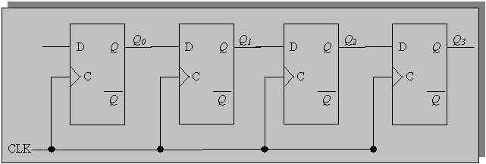

Ring Counter: A ring counter is basically a circulating shift register in which the output of the most significant stage is fed back to the input of the least significant stage. The following is a 4-bit ring counter constructed from D flip-flops. The output of each stage is shifted into the next stage on the positive edge of a clock pulse.
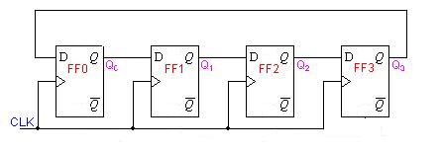
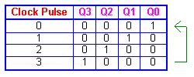

- Implement a 4-bit shift register using D- latch.
- Implement a Ring Counter using this 4-bit shift register.

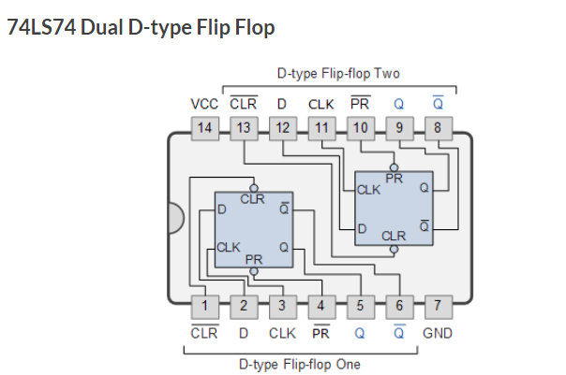

Report:
The report should cover the followings

- Name of the Experiment
- Objective
- Required Components and Equipments
- Experimental Setup (No need to draw the IC configurations)
- Results and Discussions .The discussions part must include the answers of the following questions:

  - What is the difference between a register and a latch?
  - In your design which operation you went for – parallel or serial operation?
  - What are the advantages of these two operations over one another?

